*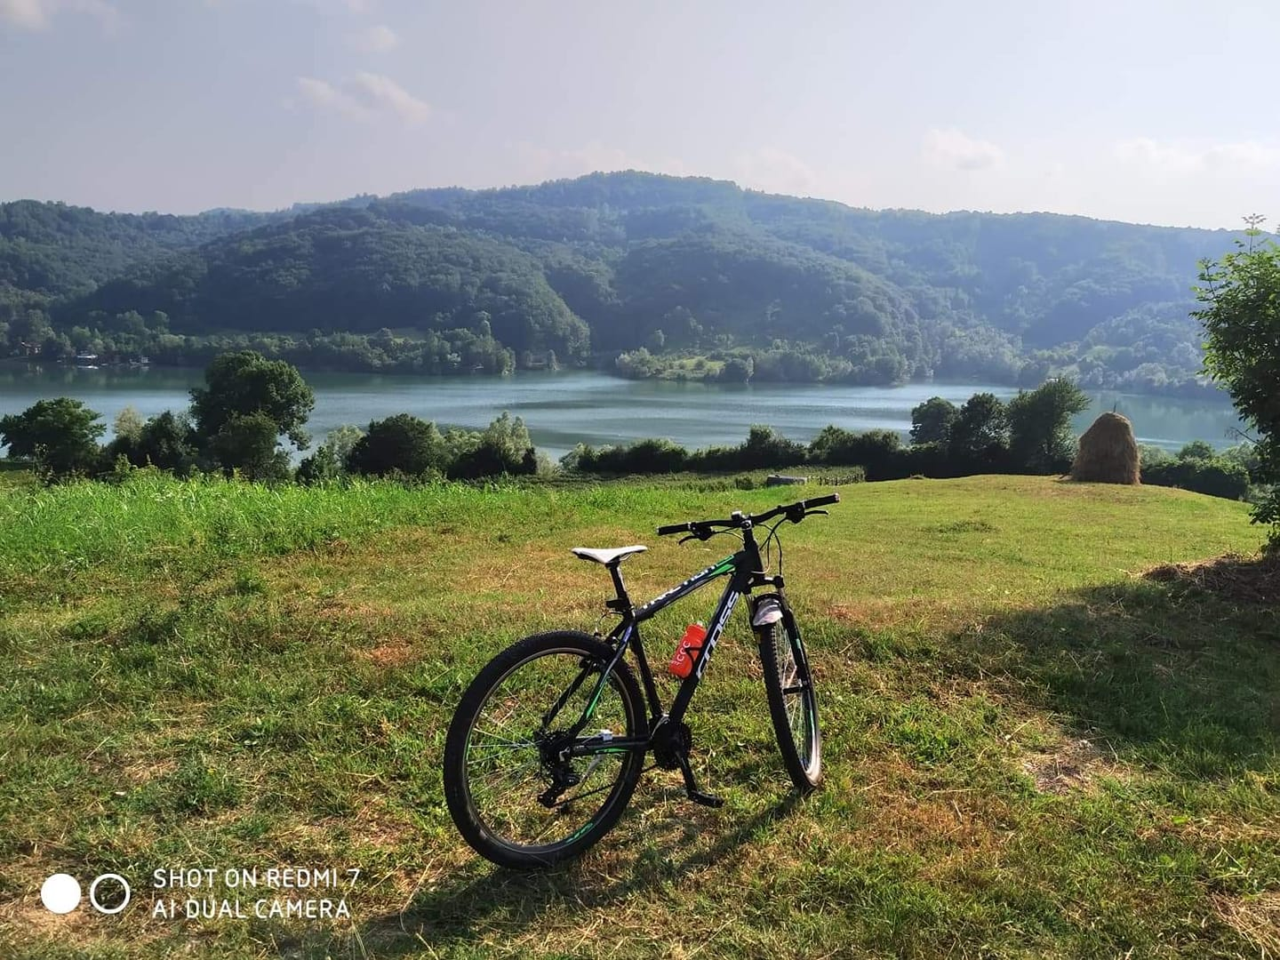***Majevica: A Success Story of Cross-Entity Co-operation**

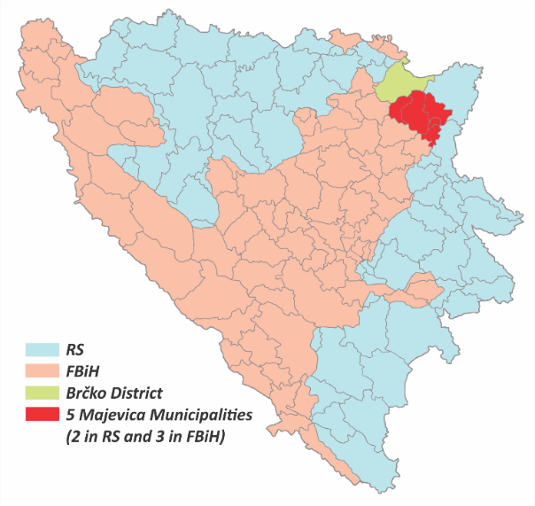**Overview –** Majevica is one of the few examples in Bosnia and Herzegovina (BiH) where communities are taking concrete steps towards reconciliation. Touching upon the territory of three municipalities[1] in the Federation of BiH and two in Republika Srpska, this mountain region is divided by the Inter-Entity Boundary Line and was the site of intense fighting during the 1992-95 conflict. Today, however, local authorities are working together on multiple initiatives for the benefit of all their residents, and in doing so, setting an important example for communities across the country to follow.

Mezgraja Lake, Ugljevik

**Background -** This process began in 2019, when the OSCE Mission to BiH supported some tentative steps towards promoting co-operation between the municipalities. What started out as simply bringing the leaders together around one table, led to a joint understanding of common challenges and opportunities, and quickly blossomed into a formalized co-operation platform focused on tourism promotion and environmental protection through the Inter – Municipal Working Group. With its network of field offices across the country, the 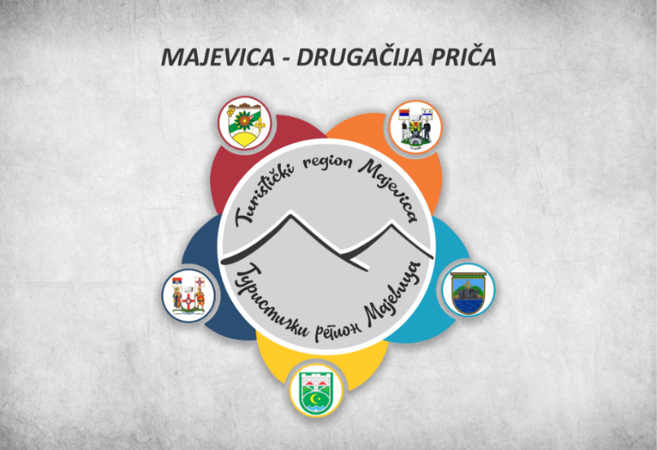OSCE Mission to BiH was uniquely placed to identify, cultivate and further support this process, including through promoting the initiative among other IC partners (see *Next Steps*).

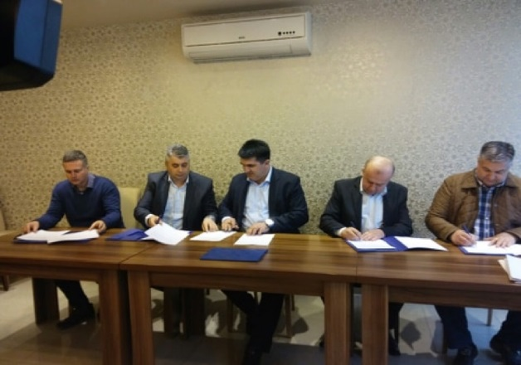**Examples of Activities** **-** The operational arm of this initiative, the Inter-Municipal Working Group, has marked and promoted a bicycle route (see page 7) which follows beautiful natural and historical sites connecting their five communities, and established an annual bicycle race gathering enthusiasts from the entire region. They also supported local institutions in enhancing their project planning skills, developed a tourism promotion plan, first - tourism package, and gathered young coders to create online promotion tools. In order to get the message out to the wider public, the working group also created a documentary Majevica – A Different Story.[2] In the sphere of waste management, they are now working on an initiative to establish a system of shared recycling facilities.

Logo – Tourist Region: Majevica

Five Mayors signing Letter of Cooperation

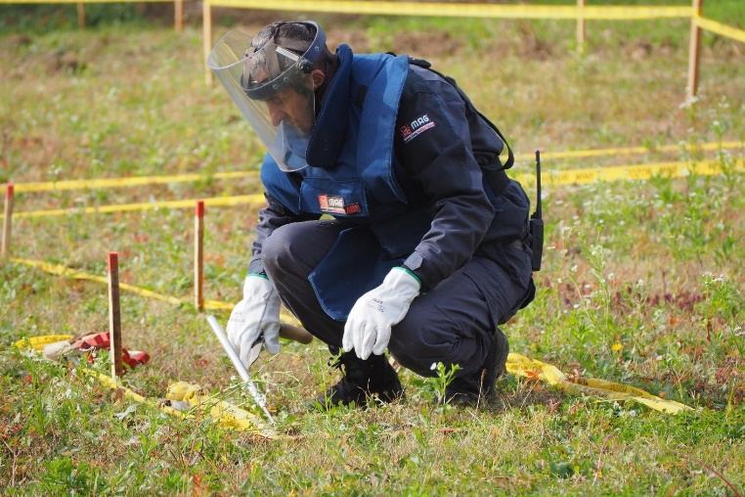**Next Steps -** Recognizing the uniqueness of this level of inter-entity cooperation, last year the German Government allocated more than 9 million EUR to de-mine the entire region, a crucial first step in promoting tourism to the area. The EU has also responded within the framework of the flagship ‘*Možemo Bolje’*[3] project, implemented jointly by OSCE, UNDP, IOM and CoE, through which funds will be directed to enhance the region’s tourism infrastructure. The Mission also donated two cars to assist the de-mining operation, support the development of project proposals to further upgrade tourism infrastructure, and bring in experts to advise on joint waste management modalities. Finally, the Mission will continue to play to its strengths by leveraging its field office to provide continuous advice and support to the mayors and the operational working group.

Majevica de-mining operation in Celic Municipality

**POINTS OF CONTACT**

|  |  |
| --- | --- |
| **Institution** | **Invitees** |
| Municipality of Lopare | Mayor Rado Savić [loparena@teol.net](mailto:loparena@teol.net); + 387 55 650 304  Željko Kerović [zeljkokerovic@gmail.com](mailto:zeljkokerovic@gmail.com); +387 65 539 967 |
| Municipality of Čelić | Mayor Admir Hrustanović [info@opcinacelic.ba](mailto:info@opcinacelic.ba); +387 35 668 650  Nermin Okanović [okanovicn@yahoo.com](mailto:okanovicn@yahoo.com); + 387 61 428 675 |
| Municipality of Sapna | Mayor Zudin Mahmutović [nacelnik@opcinasapna.ba](mailto:nacelnik@opcinasapna.ba); + 387 35 599 530  Hanifa Selamović [hannyteta@hotmail.com](mailto:hannyteta@hotmail.com); + 387 61 506 974 |
| Municipality of Teočak | Mayor Tajib Muminović [oteocak@bih.net.ba](mailto:oteocak@bih.net.ba); + 387 35 755 319  Enes Avdičević [enes_avdicevic@live.com](mailto:enes_avdicevic@live.com); + 387 61 845 252 |
| Municipality of Ugljevik | Mayor Vasilije Perić [opstinaugljevik@gmail.com](mailto:opstinaugljevik@gmail.com); +387 55 773 777  Aleksandar Krstić [alexandarkrstic89@gmail.com](mailto:alexandarkrstic89@gmail.com); + 387 65 097 341 |
| OSCE Mission to BiH | Will Richard [will.richard@osce.org](mailto:will.richard@osce.org) +387 67 130 1901  Damir Gnjidic [damir.gnjidic@osce.org](mailto:damir.gnjidic@osce.org) +387 67 130 0968 |

**BIOGRAPHIES OF 5 MAJEVICA MAYORS**

|  |  |
| --- | --- |
| Admir Hrustanovic***Admir Hrustanović (SBiH) Mayor of Čelić*** | * Born in 1975 in Brčko; * Graduated at the Faculty of Economics in Sarajevo; * Minister of Labor, Social Policy and Return in Tuzla Canton Government from July 2019 to January 2021; * Member of SBiH; * Mayor of Čelić since 2020. |

|  |  |
| --- | --- |
| https://radosavic.opstinalopare.com/wp-content/uploads/2012/09/rado_savic.jpg***Rado Savić (SDS) Mayor of Lopare*** | * Born in 1975 in Lopare; * Graduated Medical Faculty in Belgrade in 2001, specialized in gynecology in 2008; * Speaks German; * Worked at the Lopare Health Center since 2002; * RSNA member in the mandate 2006-2010. * Member of SDS since 2004, SDS Deputy President since November 2019; * Lopare Mayor since 2008. |

|  |  |
| --- | --- |
| http://opcinasapna.ba/v4/images/Nacelnik.png  ***Zudin Mahmutović (SDA) Mayor of Sapna*** | * Born in Sapna in 1971; * Graduated at the Faculty of Philosophy in Tuzla, primary school teacher; * He was Minister of Veterans´ Affairs of Tuzla Canton, as well as an advisor to the Prime Minister in the Government of Tuzla Canton; * He was a member of the Patriotic League and a member of the Army of BiH; * Member of SDA; * Mayor of Sapna since 2016. |

|  |  |
| --- | --- |
| https://www.opcinateocak.ba/images/news/tajib_muminovic.jpg  ***Tajib Muminović (SDA) Mayor of Teočak*** | * Born in 1964 in Teočak; * Graduated Faculty of Mining and Geology in Tuzla; * Participated in the war as a member of the Army of BiH from April 1992 to October 1994; * Member of the Tuzla Canton Assembly from 1998 to 2000; * SDA Tuzla Canton Board member; * Mayor of Teočak since 1994. |

|  |  |
| --- | --- |
| VASILIJE PERIĆ: I U CARSTVU NEBESKOM PATRIJARH IRINEJ ĆE SE MOLITI ZA SVOJ  ROD :: Semberija INFO ::  ***Vasilije Perić (SDS) Mayor of Ugljevik*** | * Born in Bjeljina in 1965; * Graduated at the Faculty of Economics in Brčko in 1990; * President of the Municipal Assembly of Ugljevik from 2000 to 2001; * Member of SDS; * Mayor of Ugljevik since 2001. |

**TOURISM POTENTIAL OF MAJEVICA**

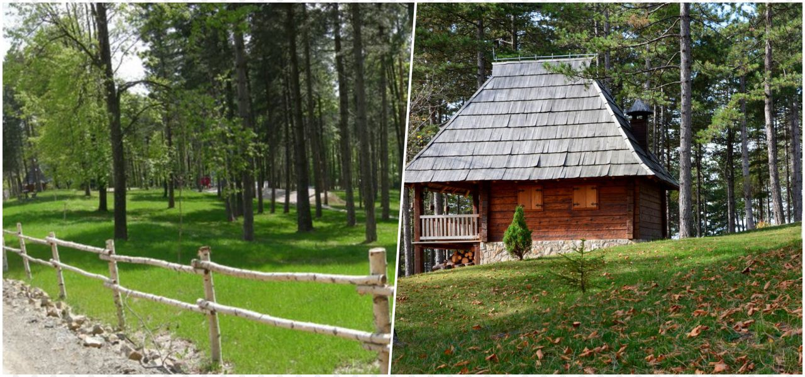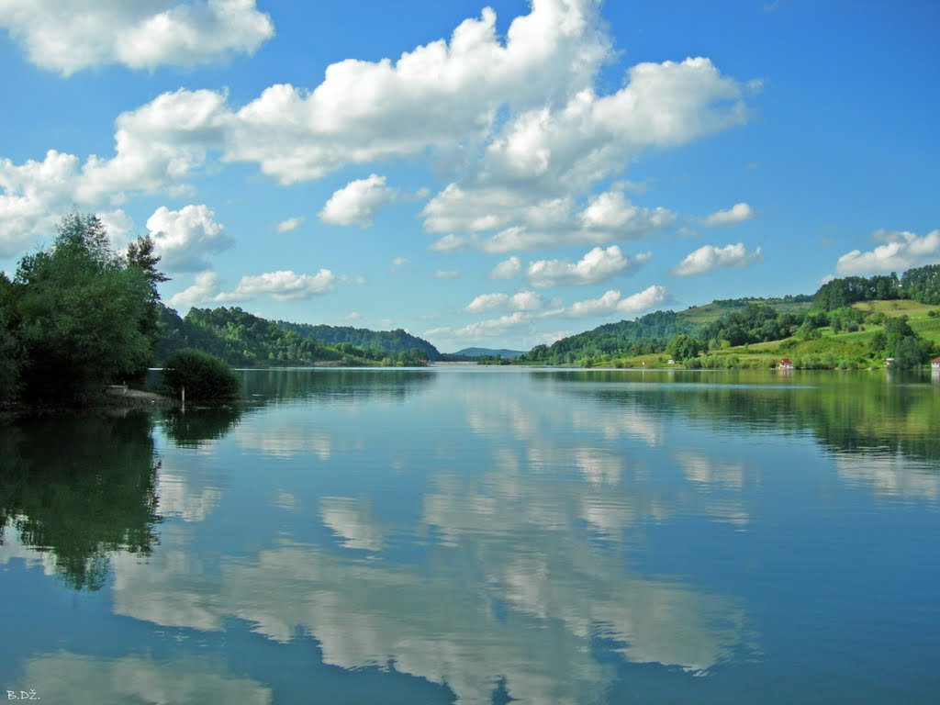

*Majevica picnic site*

Sniježnica Lake

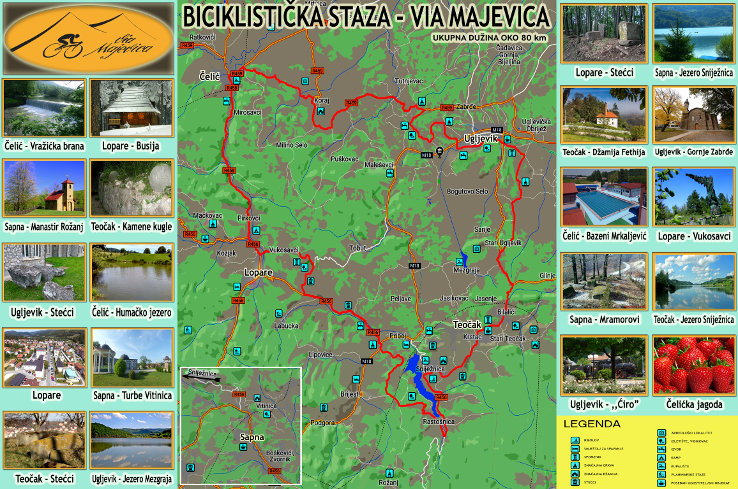**VIA MAJEVICA BICYCLE ROUTE**

Via Majevica - Bicycle Route Map

1. Čelić, Teočak and Sapna in the Federation of BiH, and Lopare and Ugljevik in Republika Srpska,
2. <https://www.youtube.com/watch?v=mbaorgXEpEo&list=PLJy3Jv9C9iXSvTJYra41B_UHVD9p1NzI4&index=1>
3. [Empowering Trust and Cohesion in Bosnia and Herzegovina’s Communities | OSCE](https://www.osce.org/mission-to-bosnia-and-herzegovina/525885)